Factor Analysis

Notes
Output Created |  | 28-JUN-2021 13:46:21
Comments
Input | Active Dataset | DataSet33
Input | Filter | <none>
Input | Weight | <none>
Input | Split File | <none>
Input | N of Rows in Working Data File | 273
Missing Value Handling | Definition of Missing | MISSING=EXCLUDE: User-defined missing values are treated as missing.
Missing Value Handling | Cases Used | LISTWISE: Statistics are based on cases with no missing values for any variable used.
Syntax |  | FACTOR  /VARIABLES ZConfirmed ZDeaths ZRecovered  /MISSING LISTWISE  /ANALYSIS ZConfirmed ZDeaths ZRecovered  /PRINT UNIVARIATE INITIAL CORRELATION EXTRACTION ROTATION  /FORMAT SORT  /PLOT EIGEN  /CRITERIA FACTORS(3) ITERATE(25)  /EXTRACTION PC  /CRITERIA ITERATE(25)  /ROTATION VARIMAX  /METHOD=COVARIANCE.
Resources | Processor Time | 00:00:00.45
Resources | Elapsed Time | 00:00:00.33
Resources | Maximum Memory Required | 1984 (1.938K) bytes

Descriptive Statistics
 | Mean | Std. Deviation | Analysis N
ZConfirmed | .69148055 | .999999175 | 91
ZDeaths | .62170110 | .999999393 | 91
ZRecovered | .55237055 | .999999196 | 91

Correlation Matrix
 |  | ZConfirmed | ZDeaths | ZRecovered
Correlation | ZConfirmed | 1.000 | .991 | .956
Correlation | ZDeaths | .991 | 1.000 | .980
Correlation | ZRecovered | .956 | .980 | 1.000

Communalities
 | Raw |  | Rescaled
 | Initial | Extraction | Initial | Extraction
ZConfirmed | 1.000 | 1.000 | 1.000 | 1.000
ZDeaths | 1.000 | 1.000 | 1.000 | 1.000
ZRecovered | 1.000 | 1.000 | 1.000 | 1.000

Extraction Method: Principal Component Analysis.

Total Variance Explained
 | Component | Initial Eigenvaluesª |  |  | Extraction Sums of Squared Loadings
 | Component | Total | % of Variance | Cumulative % | Total | % of Variance
Raw | 1 | 2.952 | 98.386 | 98.386 | 2.952 | 98.386
Raw | 2 | .045 | 1.505 | 99.891 | .045 | 1.505
Raw | 3 | .003 | .109 | 100.000 | .003 | .109
Rescaled | 1 | 2.952 | 98.386 | 98.386 | 2.952 | 98.386
Rescaled | 2 | .045 | 1.505 | 99.891 | .045 | 1.505
Rescaled | 3 | .003 | .109 | 100.000 | .003 | .109

Total Variance Explained
 | Component | Extraction Sums of Squared Loadingsª | Rotation Sums of Squared Loadings
 | Component | Cumulative % | Total | % of Variance | Cumulative %
Raw | 1 | 98.386 | 1.556 | 51.861 | 51.861
Raw | 2 | 99.891 | 1.438 | 47.942 | 99.803
Raw | 3 | 100.000 | .006 | .197 | 100.000
Rescaled | 1 | 98.386 | 1.556 | 51.861 | 51.861
Rescaled | 2 | 99.891 | 1.438 | 47.942 | 99.803
Rescaled | 3 | 100.000 | .006 | .197 | 100.000

Extraction Method: Principal Component Analysis.
a. When analyzing a covariance matrix, the initial eigenvalues are the same across the raw and rescaled solution.

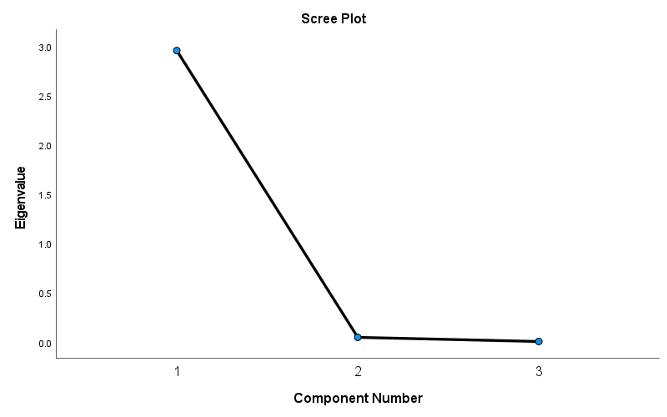

Component Matrixª
 | Raw |  |  | Rescaled
 | Component |  |  | Component
 | 1 | 2 | 3 | 1 | 2 | 3
ZDeaths | .999 | -.028 | -.046 | .999 | -.028 | -.046
ZConfirmed | .991 | -.134 | .030 | .991 | -.134 | .030
ZRecovered | .987 | .163 | .017 | .987 | .163 | .017

Extraction Method: Principal Component Analysis.ª
a. 3 components extracted.

Rotated Component Matrixª
 | Raw |  |  | Rescaled
 | Component |  |  | Component
 | 1 | 2 | 3 | 1 | 2 | 3
ZConfirmed | .807 | .590 | .000 | .808 | .590 | .000
ZDeaths | .738 | .670 | .076 | .738 | .670 | .076
ZRecovered | .599 | .801 | .013 | .599 | .801 | .013

Extraction Method: Principal Component Analysis.
Rotation Method: Varimax with Kaiser Normalization.ª
a. Rotation converged in 3 iterations.

Component Transformation Matrix
Component | 1 | 2 | 3
1 | .721 | .692 | .030
2 | -.693 | .721 | .001
3 | .021 | .021 | -1.000

Extraction Method: Principal Component Analysis.
Rotation Method: Varimax with Kaiser Normalization.

